SMART DISPLAY MODULE
SPECIFICATION

4.3 Inch Smart Display with TOUCH
Model: | PLCM-UES31S043H800V480C-U
MCU： | ESP32-S31-WROOM-3
PCB： | UES31S043H800V480C-U
Display： | 4.3" IPS, 800 × 480, ST7262, RGB666/888, GT911 CTP
Version: | V1.0
Date: | 2026-9-3

Customer Confirmation
Approved by | Notes

REVISION HISTORY
Revision | Date | Contents of Revision Change | Remark
V1.0 | 20260903

TABLE of CONTENTS

1. Introduction 4
1.1 Product Features 4
1.2 Applications 6
1.3 Product Naming 6
2. Product information 7
2.1 Interface Description 7
2.2 GPIO Definition 10
2.3 Display Information 11
2.4 LCD RGB timing (verified) 11
2.5 Audio Interface 11
2.6 H1 header (2 × 10, 2.54 mm), top to bottom 12
2.7 USB 2.0 Interface 12
2.8 UART / RS485 / CAN 13
2.9 Storage, Keys, LED 14
2.10 Voltage & Current 14
2.11 Reliability Test 14
3. Functional Block Diagram 15
4. MECHANICAL DRAWING 16
5. Detailed information (codes, drawings...) 17

Introduction
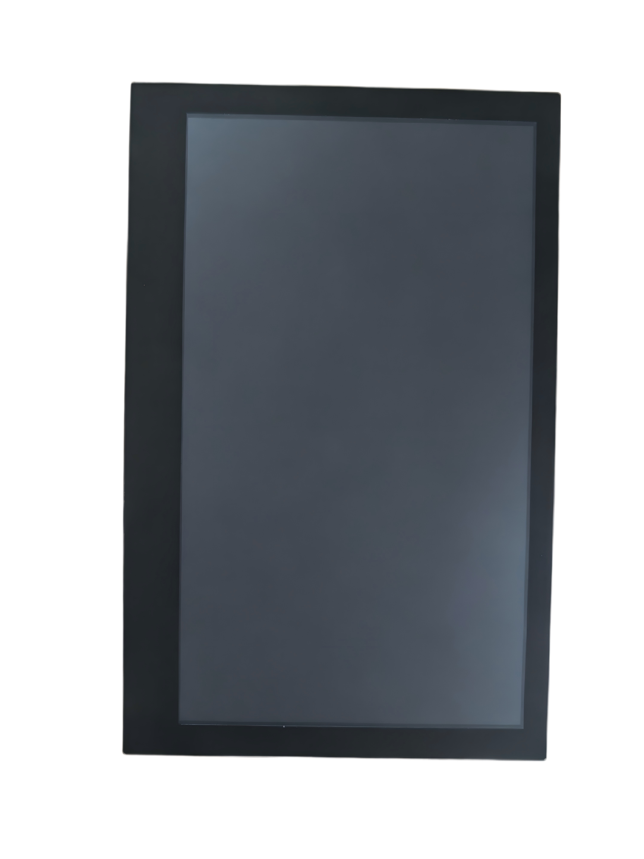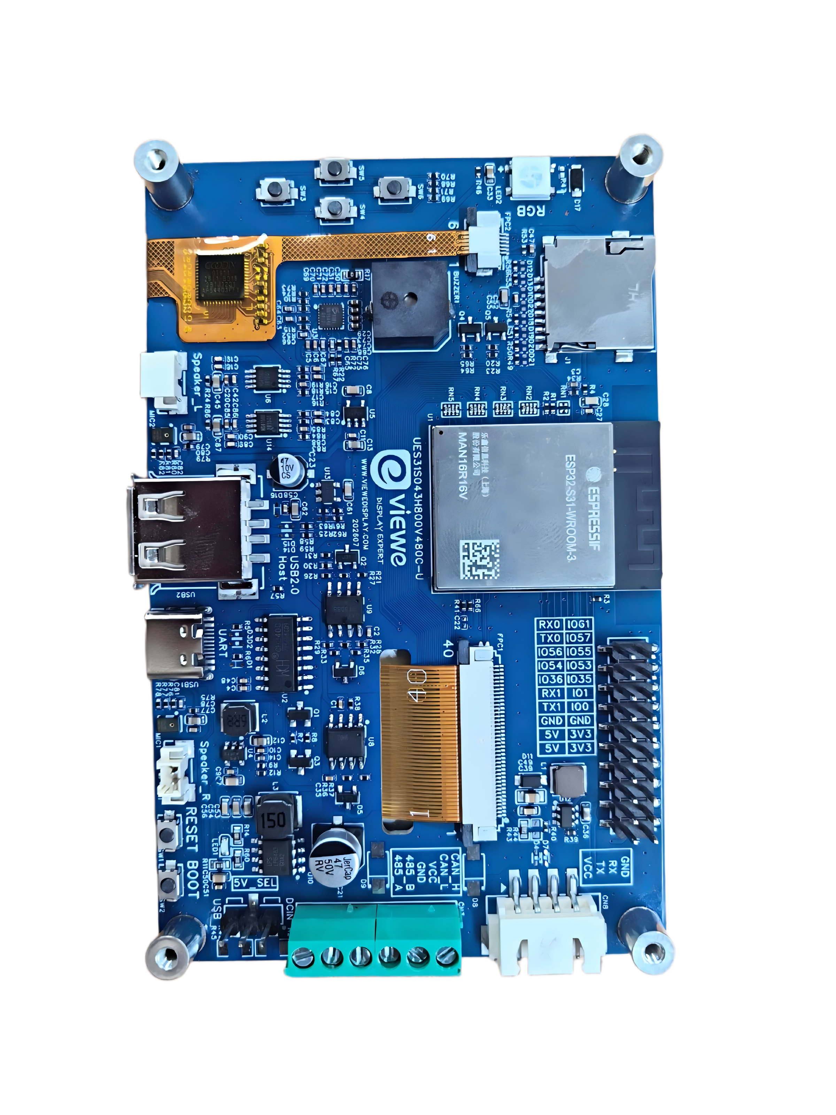
PLCM-UES31S043H800V480C-U is a high-performance smart display module designed by VIEWE. It is based on the Espressif ESP32-S31-WROOM-3 module and a 4.3-inch RGB capacitive touch panel (800 × 480). The LCD and touch devices are the same as those used on UEDX80480043E-WB-B (ST7262 driver IC and GT911 CTP). The main board is a new design around ESP32-S31: a dual-core 32-bit RISC-V MCU running at up to 320 MHz, with Wi-Fi 6, Bluetooth 5.4 (LE) plus Bluetooth Classic, USB 2.0 High-Speed OTG, stereo audio, SDIO 3.0 storage, and RS485 / CAN industrial interfaces.
Notice: ESP32-S31 is a preview device. ESP-IDF builds must use the --preview option (for example: idf.py --preview set-target esp32s31). Module ratings follow the Espressif ESP32-S31-WROOM-3 datasheet (pre-release). New designs that need USB 2.0 High-Speed, Wi-Fi 6, or on-board codec audio should use this S31 board rather than the ESP32-S3。

1.1 Product Features
CPU:
- Processor
- ESP32-S31 RISC-V 32-bit dual-core processor, main frequency up to 320 MHz, plus a ULP-RISC-V coprocessor.
- 2.4 GHz Wi-Fi 6 (IEEE 802.11b/g/n/ax, HT20/40, up to 150 Mbps), Bluetooth 5.4 LE (including LE Audio), Bluetooth Classic (BR/EDR), and IEEE 802.15.4 (Zigbee / Thread).
- On-module PCB antenna.
- Hardware security: Secure Boot, Flash/PSRAM encryption, cryptographic acceleration, and TEE. See the chip datasheet for details.

- Memory
- On-chip: 320 KB ROM, 512 KB SRAM, 32 KB low-power SRAM.
- Typical module configuration on this product: 16 MB Quad SPI Flash + 16 MB Octal SPI PSRAM (ESP32-S31-WROOM-3-N16R16V).
- Flash and PSRAM can be accessed in parallel.

- Peripheral Interfaces
- USB Type-C port for 5 V power, firmware download, and serial debug (CH340C bridged to UART0).
- USB Type-A port connected to the dedicated USB 2.0 High-Speed OTG PHY (USB_DP / USB_DM, not GPIOs). Host 5 V is sourced through TPS2051C (~500 mA). VBUS-EN is hard-wired high and is not MCU-controlled.
- On-board MicroSD slot, 4-bit SDMMC / SDIO 3.0.
- ES8389 stereo codec, dual NS4150B speaker amplifiers, dual analog microphones, and L/R speaker connectors.
- RS485 (SIT3088E, hardware automatic direction) and CAN (SIT1050T + on-chip TWAI) on a 6-pin terminal.
- 2 × 10 pin 2.54 mm header (H1) bringing out UART0/UART1, I2C, RS485/CAN GPIOs, 3.3 V / 5 V / GND.
- Four ADC keys, RESET / BOOT, WS2812B RGB LED, and a 3 kHz passive buzzer.
For more information on ESP32-S31-WROOM-3, please refer to the Espressif module datasheet (pre-release).

Display
- Size: 4.3 Inch
- Resolution: 800 *480
- Pixel Arrangement：RGB Vertical Stripe
- Interface Mode：40PIN RGB 24bits
- Driver IC： ST7262E43-G4
- Touch IC: GT911
- Brightness: 400 cd/m²
- Touch: CTP
- Verified timing: PCLK 18 MHz, negative polarity; HSYNC 1 / 40 / 20; VSYNC 1 / 10 / 5.
More information about Display can be found here:Display Specification.pdf

Other
- Operation Temperature: −20 ~ 70 °C (limited by the LCD).
- Storage Temperature: −30 ~ 80 °C.
- MCU module rating: −40 ~ 85 °C.

1.2 Applications
With rich connectivity and powerful processing capabilities, the UEDX80480043E-WB-B is an ideal choice for IoT devices in the following areas:
• Smart Home Control Panels
• Industrial Automation HMI
• Smart Appliances
• Consumer Electronics
• Wireless Data Loggers
• Touch Screen Interfaces
• Educational Learning Platforms

1.3 Product Naming
Field | Code | Meaning
Form | PLCM | PCB+LCM(Display)
Brand / series | UE | VIEWE smart display module
MCU | S31 | ESP32-S31-WROOM-3
Size | S043 | 4.3 inch
Resolution | H800V480 | 800 × 480
Touch | C | Capacitive (GT911)
Bus | U | UART/RS485/I2C/CAN/USB 2.0 High-Speed OTG

Product information

2.1 Interface Description

This module achieves efficient communication with the main control unit via UART, RS485 and CAN buses, and supports USB 2.0 High-Speed OTG functions to meet diverse data interaction requirements. The capacitive touch screen adopts the GT911 solution to deliver smooth and responsive touch experience. The 4.3-inch screen features an 800×480 high-definition resolution, ensuring clear and delicate display content. Integrated with the ESP32-S3-WROOM-3 MCU, it balances high-performance processing and low-power operation. Suitable for various industrial and commercial application scenarios, it provides stable and reliable visual interaction support for devices.

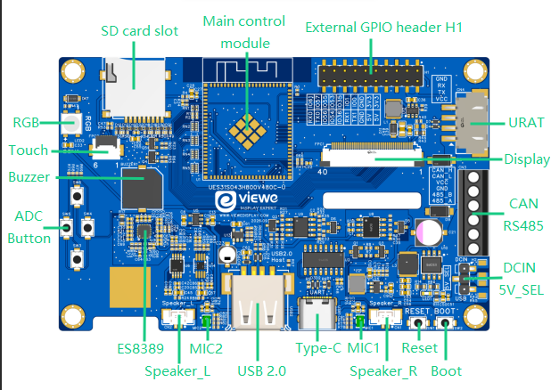

1、Main Control Module:
ESP32-S31-WROOM-3 Dual-core RISC-V, up to 320 MHz, 16 MB Flash + 16 MB PSRAM, PCB antenna.
2、Display Interface:
40-pin RGB output. The panel is 24-bit capable; this board wires RGB666 (R2–R7 / G2–G7 / B2–B7). See the Display Interface table.
3、SD Card Slot：
SPI interface connected for external storage expansion, Please refer to Section 2.9 below for detailed information.
4、Touch interface：
I2C (SDA = GPIO0, SCL = GPIO1) to GT911. INT and RST are present on the 6-pin FPC; verified examples leave them unused (NC).
5、USB Type-C interface：
5 V DC input, programming, and serial debug through CH340C
6、USB Type-A:
USB 2.0 High-Speed OTG PHY (USB_DP / USB_DM). Host 5 V via TPS2051C. VBUS-EN is pulled high by hardware.Please refer to Section 2.7 below for detailed information.
- UART helper (4-pin):
GND / RX / TX / VCC for an external serial adapter.The 4-pin pitch of 2.5 mm
8、RGB-LED (WS2812B)：
one WS2812B, DIN = GPIO37, powered from 5 V with a level-shift network.Please refer to Section 2.9 below for detailed information.
9、Boot Buttons：
BOOT button (GPIO61) for firmware download mode.
10、Reset Buttons：
RESET button (CHIP-EN) for resetting the board.
11、External GPIO header H1:
2 × 10 pins, 2.54 mm. See Section 2.2. Please refer to Section 2.6 below for detailed information.
12、Industrial terminal CN3 (CAN/RS485):
CAN_H, CAN_L, VCC, GND, 485_B, 485_A，Please refer to Section 2.8 below for detailed information.
13、Audio：
Dual-channel speaker interface Speaker L / R (CN2 / CN1) with a 2-pin pitch of 1.25 mm, and on-board dual microphones MIC1 / MIC2 deliver high-quality audio via ES8389 and NS4150B，Please refer to Section 2.5 below for detailed information.
14、ADC Button：
ADC key array SW3–SW6 on GPIO42. Please refer to Section 2.9 below for detailed information.
15、Buzzer:
BEEP_EN = GPIO46, high = on, 3 kHz passive type.
16、DCIN / 5V_SEL:
external 5 V input and 5 V source-selection jumper.

Display Interface:
Pin No. | Symbol | I/O | Description
1 | LEDK | P | Power supply for backlight cathode
2 | LEDA | P | Power supply for backlight anode
3 | GND | P | Power ground
4 | VDD | P | Logic supply, 3.3 V
5-12 | R0-R7 | I | Red data. This board uses R2–R7 (GPIO2–7). R0/R1 = NC
13-20 | G0-G7 | I | Green data. This board uses G2–G7 (GPIO8–13). G0/G1 = NC
21-28 | B0-B7 | I | Blue data. This board uses B2–B7 (GPIO14–19). B0/B1 = NC
29 | GND | P | Power ground
30 | CLK | I | Pixel clock, negative polarity (GPIO40)
31 | DISP | I | Standby mode. Normally pulled high
32 | HSYNC | I | Horizontal sync, negative polarity (GPIO44)
33 | VSYNC | I | Vertical sync, negative polarity (GPIO45)
34 | DEN | I | Data enable. Display access is enabled when DE is “H” (GPIO43)
35 | NC | I | Dummy
36 | GND | P | Power ground
37 | XR | - | Dummy
38 | YD | - | Dummy
39 | XL | - | Dummy
40 | YU | - | Dummy
I：Input；O：Output；P：Power

TP Interface:
Pin No. | Symbol | I/O | Description
1 | RST | P | Touch reset on FPC; not used
2 | 3.3V | P | 3.3 V logic supply
3 | GND | P | Power ground
4 | INT | I | Touch interrupt on FPC;TP INT = GPIO38
5 | SDA | I | SDA = GPIO0, shared with ES8389
6 | SCL | P | SCL = GPIO1, 400 kHz, shared with ES8389

2.2 GPIO Definition
GPIO Number | Current Usage | Function Description
CHIP-EN | Reset | RESET button (SW1)
GPIO0 | I2C SDA | GT911 + ES8389. Pulled high at reset (normal boot). Not the BOOT key; also on H1
GPIO1 | I2C SCL | GT911 + ES8389; also on H1
GPIO2–7 | LCD-R2–R7 | LCD red data, high 6 bits
GPIO8–13 | LCD-G2–G7 | LCD green data, high 6 bits
GPIO14–19 | LCD-B2–B7 | LCD blue data, high 6 bits
GPIO20–23 | SD-D0–D3 | SDMMC 4-bit data
GPIO24 | SD-CLK | SDMMC clock
GPIO25 | SD-CMD | SDMMC command
USB_DP / USB_DM | USB 2.0 HS PHY | Dedicated module pins. Do not configure as GPIO
GPIO33 | UART1 TX | Verified as UART1 TX. Also a USB Serial/JTAG pad
GPIO34 | UART1 RX | Verified as UART1 RX
GPIO35 | RS485 TX | SIT3088E DI; S8050 auto-drives DE/~RE; also on H1
GPIO36 | RS485 RX | SIT3088E RO; also on H1
GPIO37 | WS2812 DIN | On-board XL-5050RGBC-WS2812B
GPIO39 | LCD-BL-EN | Backlight enable, active high
GPIO40 | LCD-PCLK | Pixel clock, 18 MHz, negative polarity
GPIO42 | ADC KEY | SW3–SW6 resistor ladder, ADC1, ~0–2 V usable range
GPIO43 | LCD-DE | Data enable
GPIO44 | LCD-HS | Horizontal sync (GPIO number, not USB_DM)
GPIO45 | LCD-VS | Vertical sync (GPIO number, not USB_DP)
GPIO46 | BEEP-EN | Buzzer, active high; 3 kHz PWM recommended
GPIO47 | PA-EN | NS4150B amplifier enable, active high
GPIO48 | I2S MCLK | Present on schematic; firmware examples leave NC (codec no_mclk)
GPIO49 | I2S BCK | ES8389 bit clock
GPIO50 | I2S WS | ES8389 word select / LRCK |  |  | SD |  | I2C |  | Reset
GPIO51 | I2S DOUT | MCU → ES8389 DAC
GPIO52 | I2S DIN | ES8389 ADC → MCU |  |  | RS485 |  | UART1 |  | USB2.0
GPIO53 | CAN TX | SIT1050T TXD
GPIO54 | CAN RX | SIT1050T RXD |  |  | Buzzer |  | LCD |  | RGB
GPIO55–57 | H1 GPIO | Broken out on H1
TX0（IO58） / RX0（IO59） | UART0 | CH340C download / log; also on H1 |  |  | CAN |  | I2S |  | PA-EN
GPIO60 | SD-CTRL | SD 3.3 V power switch, active low
GPIO61 | BOOT | BOOT button (SW2); also on H1 |  |  | GPIO |  | UART0 |  | Boot

2.3 Display Information
Item | Specification | Unit | Remark
Pixel Driving element | IPS TFT | - | -
Screen Size | 4.3 | Inch | Diagonal
Resolution | 800(W)*3(RGB)*480(H) | Dots | -
Interface | RGB 24bits | - | 40PIN
Module Power Consumption | 1.04 | Watt | Typ.
Active Area | 95.04(W)*53.86(H) | mm | -
Pixel pitch (W*H) | 0.1188(W)*0.1122(H) | mm | -
Module Size (W*H*D) | 105.52(W)*67.17(H)*2.8(D) | mm | Tolerance:±0.2
Luminance | 400 | cd/m² | Typ.
Viewing Direction | All | O’clock | -
Display Color | 16.2M | Colors | 24bits

2.4 LCD RGB timing (verified)
Parameter | Value
PCLK | 18 MHz, pclk_active_neg = true
Horizontal resolution | 800
Vertical resolution | 480
HSYNC pulse / back porch / front porch | 1 / 40 / 20
VSYNC pulse / back porch / front porch | 1 / 10 / 5
Framebuffer | RGB888 in PSRAM, one frame buffer

2.5 Audio Interface
The audio codec is Everest ES8389 (I2C 7-bit address 0x20). I2S0 is used in full duplex. 48 kHz / 16-bit / stereo playback and record have been verified. MCLK is not required (codec configured with no_mclk). Dual NS4150B Class-D amplifiers drive the left and right speakers. PA_EN = GPIO47. MIC1 and MIC2 are on-board analog microphones.
Signal | GPIO / Device | Description
I2C SDA / SCL | GPIO0 / GPIO1 | Shared with GT911, 400 kHz
I2S BCK | GPIO49 | Bit clock
I2S WS | GPIO50 | Word select / LRCK
I2S DOUT | GPIO51 | DAC playback
I2S DIN | GPIO52 | ADC record
I2S MCLK | NC in firmware | Optional on schematic
PA_EN | GPIO47 | High = amplifier on
Speaker | CN1 / CN2 | NS4150B differential output, typ. 4 Ω / 3 W class

2.6 H1 header (2 × 10, 2.54 mm), top to bottom
Number | Left | Number | Right
1 | 3V3 | 2 | 5V
3 | 3V3 | 4 | 5V
5 | GND | 6 | GND
7 | GPIO0 (SDA) | 8 | TX1 (GPIO33)
9 | GPIO1 (SCL) | 10 | RX1 (GPIO34)
11 | GPIO35 (485_TX) | 12 | GPIO36 (485_RX)
13 | GPIO53 (CAN_TX) | 14 | GPIO54 (CAN_RX)
15 | GPIO55 | 16 | GPIO56
17 | GPIO57 | 18 | TX0
19 | GPIO61 (BOOT) | 20 | RX0

GPIO35/36 and GPIO53/54 on H1 are in parallel with the on-board RS485 and CAN transceivers. Do not drive both the header and the terminal at the same time. GPIO0/1 already have I2C pull-ups.

2.7 USB 2.0 Interface
ESP32-S31 integrates a USB 2.0 High-Speed OTG PHY on dedicated USB_DP / USB_DM pins (package pins 44 / 45 of the chip). These are not GPIOs and need no GPIO-matrix setup. The board provides two physical connectors:
Port | Bridge / PHY | Role | Notes
Type-C | CH340C → UART0 | Download / log / 5 V in | Hold BOOT (GPIO61), then tap RESET
Type-A | USB 2.0 HS PHY | OTG Host or Device | TPS2051C sources 5 V; VBUS-EN hard-wired high

Verified applications: (1) TinyUSB HID mouse mapped from the touch panel — class-compliant on Windows and Linux, no custom driver; (2) USB extended display — host-side IDD / vendor driver required, JPEG decode to the RGB panel. Type-A defaults to supplying 5 V as a USB Host. When the same port is used as a Device attached to a PC, avoid back-feeding VBUS from both ends.

2.8 UART / RS485 / CAN
Interface | Controller | MCU pins | External | Verified setting
UART0 | CH340C | TX0 / RX0 | Type-C / H1 | Download and monitor
UART1 | GPIO matrix | TX=33, RX=34 | H1 TX1 / RX1 | 115200 8N1
RS485 | SIT3088E + UART2 | TX=35, RX=36 | CN3 485_A / 485_B / GND | 115200 8N1, auto DE
CAN | SIT1050T + TWAI | TX=53, RX=54 | CN3 CAN_H / CAN_L / GND | 500 kbit/s, Classic CAN

CN3 terminal (follow the PCB silkscreen)
Silk | Function
CAN_H | CAN high
CAN_L | CAN low
VCC | 5 V — check jumper and load before using as a supply
GND | Common ground
485_B | RS485 B
485_A | RS485 A

RS485: DE/~RE is switched automatically from 485_TX through an S8050. Treat the port as a normal UART in software; do not configure RTS. 120 Ω termination and A-pull-up / B-pull-down are on board. CAN: 120 Ω termination on board; CAN_GND is tied to system ground through 0 Ω. Do not connect a USB-TTL adapter to A/B or CAN_H/L.

2.9 Storage, Keys, LED
Micro SD
SDMMC 4-bit: CLK = GPIO24, CMD = GPIO25, D0–D3 = GPIO20–23, SD_CTRL = GPIO60 (active low). Examples mount FAT at SDMMC_FREQ_HIGHSPEED. Assert GPIO60 low before initializing the host.
ADC keys (measured on the real board)
Key | Typical voltage | Software window | Remark
Idle | ≈ 3.3 V (pull-up) | Saturated / idle | S31 ADC 0 dB ≈ 0–2 V; idle saturates
SW3 | ≈ 0.38 V | 100–600 mV | GPIO42
SW4 | ≈ 0.82 V | 600–1080 mV | GPIO42
SW5 | ≈ 1.34 V | 1080–1605 mV | GPIO42
SW6 | ≈ 1.87 V | 1605–2200 mV | GPIO42

Two keys cannot be detected at once (inherent to the divider). Silkscreen order on some drawings does not match the measured voltages; use the table above.

2.10 Voltage & Current
Item | Conditions | Min | Typ | Max | Unit
Power Voltage | DC | - | 5.0 | - | V
Operation Current | VCC= +5V, Maximum backlight current | 80 | 320 | 500 | mA
Operation Current | VCC= +5V,backlight off | - | 100 | - | mA
Recommended power supply:5V 1A DC

2.11 Reliability Test
Item | Conditions | Min | Typ | Max | Unit
Working Temperature | 60%RH at 5V voltage | -20 | 25 | 70 | C
Storage Temperature | --- | -30 | 25 | 85 | C
Working Humidity | 25°C | 10% | 60% | 90% | RH
ESD | --- | Contact: ±4KV  Air: ±8KV |  |  | KV

Functional Block Diagram
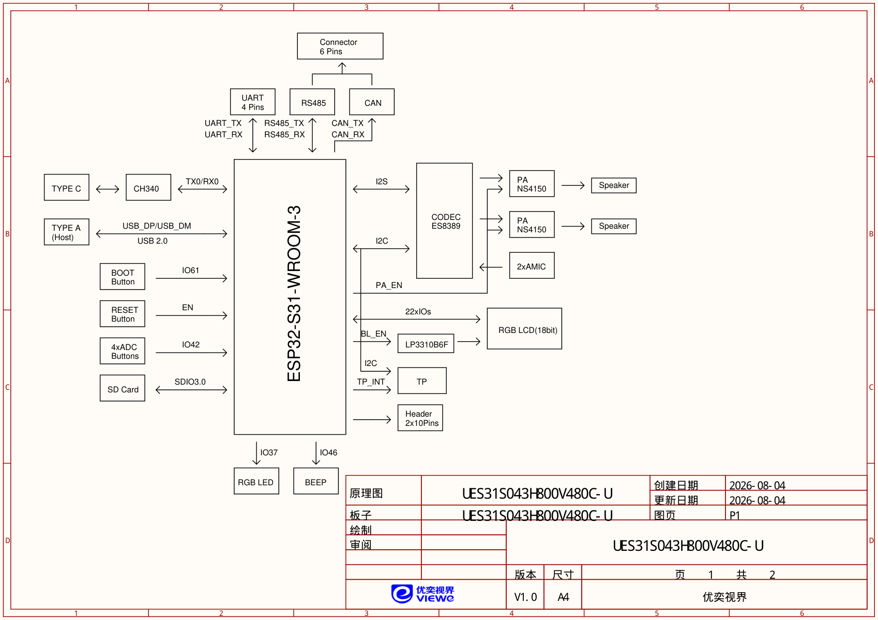
Note: ESP32-S31 includes a 2.4 GHz radio that supports Wi-Fi 6, Bluetooth 5.4 (LE), Bluetooth Classic, and 802.15.4. Because they share the same RF front-end, Wi-Fi and Bluetooth cannot transmit or receive simultaneously; the radio switches between protocols as needed. USB 2.0 High-Speed is an independent PHY and does not share that front-end.

MECHANICAL DRAWING

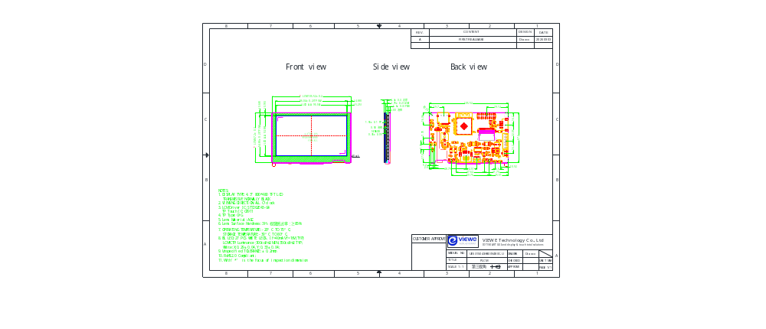

Detailed information (codes, drawings...)
Github：https://github.com/VIEWESMART/PLCM-UES31S043H800V480C-U
Gitee: https://gitee.com/VIEWESMART/PLCM-UES31S043H800V480C-U

Prompt: The materials are being developed and enriched. Please stay tuned.

